**LetsUpgrade**

**Project 1 Windows 2012 R2 base**

**Solution:-**

**URL :-** https://us-east-2.console.aws.amazon.com/ec2/v2/home?region=us-east-2#Instances:search=i-05c3c41bde2564f3f;sort=owner

**Public IP :- 18.223.15.244**

**Image:**

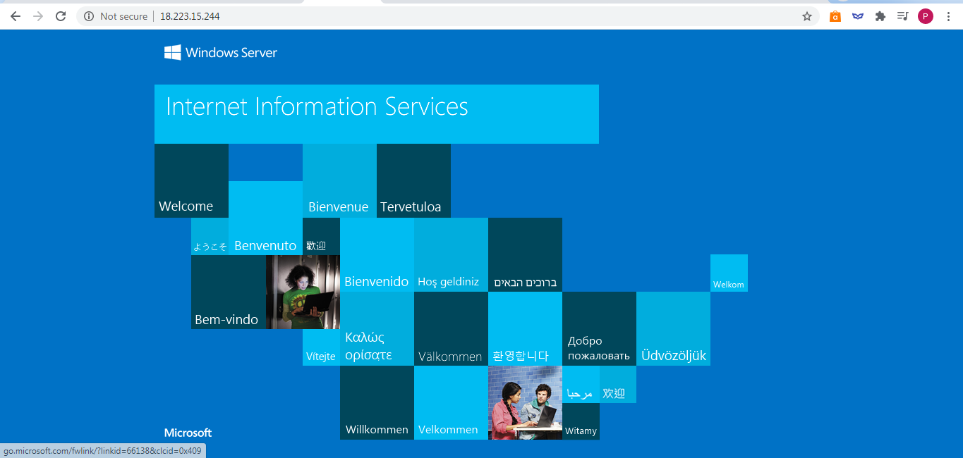

**Project 2 Ubuntu Server 18.04 LTS (HVM)**

**Solution:-**

**URL:-** https://us-east-2.console.aws.amazon.com/ec2/v2/home?region=us-east-2#Instances:instanceId=i-0858350df60b28def;sort=owner

**Public IP :-** 18.219.127.188

**Image:**

